**Computer Vision hw5**

姓名：胡嘉祐 學號：R07922162 系級：資工碩一

**1.result:**

dilation erosion



closing opening



2. Main Code

1. dilation :

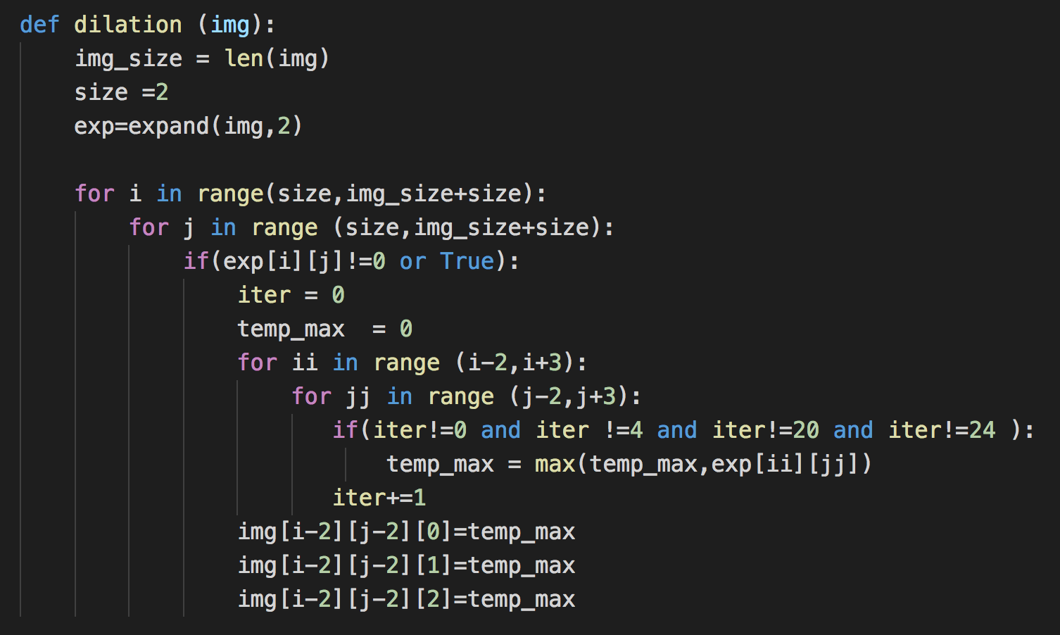

1. erosion :

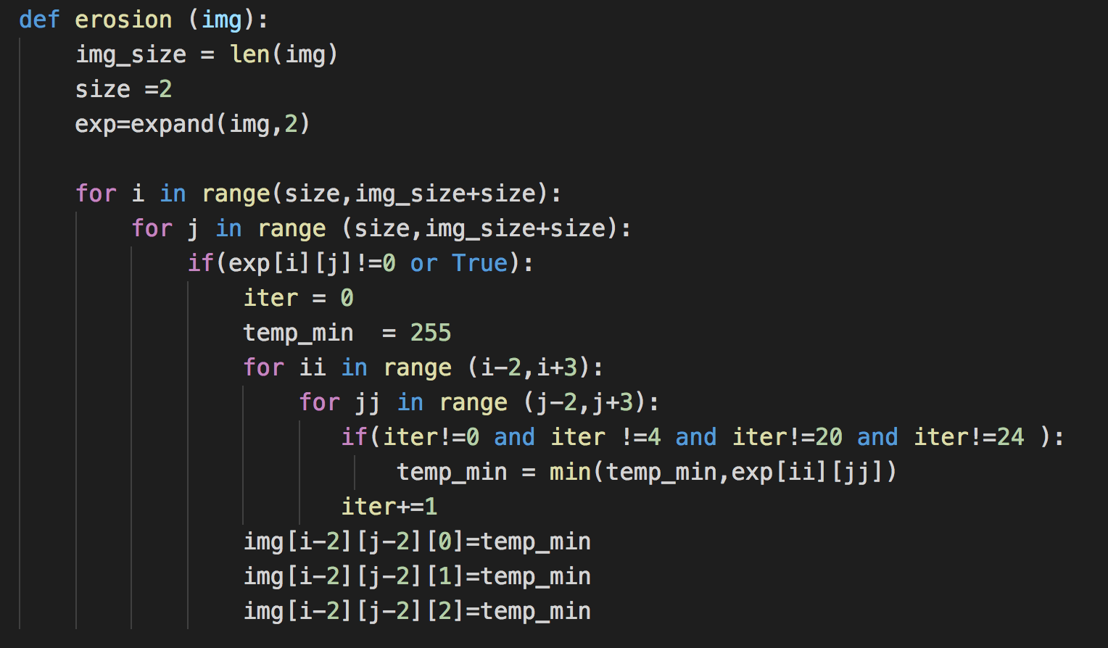

1. opening and closing:

opening : do erosion then dilation

closing : do dilation then erosion

1. main:

